EIB signs Cooperative Financial Mechanism (CFM) arrangement

Brussels - 09 December, 2019

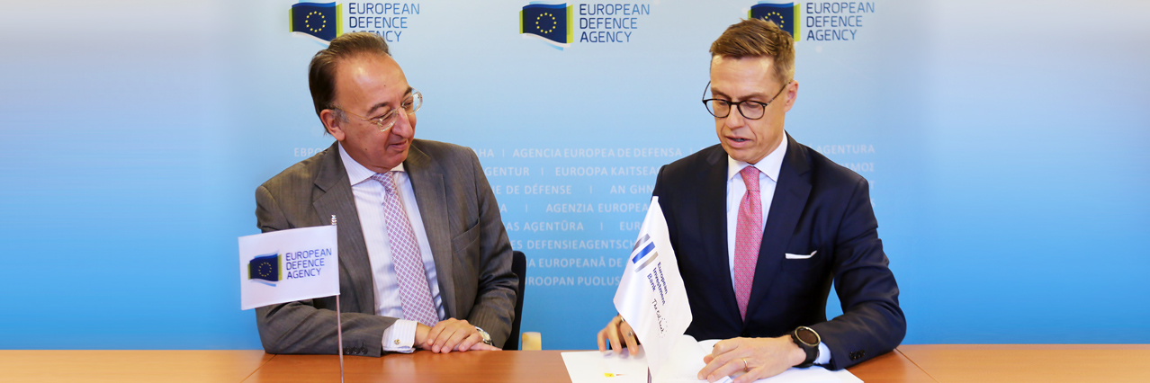

**An important step towards incentivising and facilitating the launch of collaborative defence capability and research programmes in Europe was made today when Alexander Stubb, the Vice-President of the European Investment Bank (EIB), signed the programme arrangement setting up a Cooperative Financial Mechanism (CFM). The signing took place during a meeting with EDA Chief Jorge Domecq at the Agency’s premises. Initiated by EDA, the CFM was negotiated over the past three years. It is designed to overcome the recurrent problem of unsynchronised defence budgets in participating Member States which can hinder or impede the launch of collaborative defence projects.**

So far, 10 participating Member States (Belgium, Bulgaria, Cyprus, France, Greece, Hungary, Lithuania, the Netherlands, Portugal, Spain) have already signed the Programme Arrangement or declared their intention to join the programme. More countries signalled their willingness to join the programme in the coming weeks. Developed as a so-called ‘Category A’ programme of the Agency, the CFM is entirely voluntary. Member States can freely decide if they wish to participate, contribute and support projects.

Today, the launch of collaborative defence capability and research projects is sometimes delayed or hampered by the fact that defence budgetary availabilities might differ among partners, for instance for an unexpected budgetary restriction or a shift in national priorities. As a result, it happens that countries interested in a collaborative project cannot join or have to postpone their participation because the required funding is not approved or available at a particular moment. The CFM, acting as trusted platform offering mutual inter-state help, or alternatively outside support from the EIB, was established to mitigate this problem. It will enter into force at the date of the signature of the last country having declared its intention to join.

EDA Chief **Jorge Domecq** stated: *“The Agency’s role is to promote and incentivise collaborative defence projects in Europe and to help create the right conditions for that. The CFM adds a very powerful instrument to our toolbox in the context of an enhanced momentum for defence cooperation fostered by the EU defence initiatives. In future, mismatching budgetary cycles or provisional gaps in funding should no longer exclude member states from participating in multinational programmes”.*

EIB Vice-President **Alexander Stubb**commented: *“Europe has to be at the forefront of the development of key strategic defence technologies, including AI and digitalisation. With cooperation we can improve EU efficiency and innovation ability and strengthen EU capacity to prevent and respond to hybrid threats. A lack of access to suitable financing solutions allowing to better synchronize joint resources is seen as one of the major impediments to the launch or implementation of defence related cooperative projects. This is where the EU bank comes into play. Via the CFM, the EIB can strengthen its lending in support of public sector projects, with, inter alia, potential investments in the fields of dual-use RDI of defence or cybersecurity technologies, including projects envisaged under the EU’s Permanent Structured Cooperation PESCO.”*

Two pillar structure

The CFM will be structured in two pillars:

* the first pillar foresees the European Investment Bank (EIB) as the sole lender through the conclusion of bilateral framework loan agreements between EIB and the interested Member State having joined the CFM arrangement (CFM Member). To obtain the EIB’s financial support, projects submitted must respect the eligibility requirements set by the Bank’s lending policy, while the volume of the lending facility and the interest rate applied are negotiated on a case-by-case basis by the EIB and the interested CFM Member. The EIB involvement is supported and facilitated by the EDA which will act as the ‘Facility Agent’ on behalf of EIB under its instructions and responsibility, serving as a primary point of contact between the EIB and the beneficiary CFM Member in the technical assessment of the feasibility of each project;
* the second pillar provides for a State-to-State support facility, through a system of reimbursable advances and deferred payments. It can be used to support any defence related project. The facility is structured as a set of individual bank accounts which are opened and managed by the EDA under the control of the CFM Members. Within that pillar, any CFM Member can submit a request for financial support to other CFM Members being part of a same collaborative project. While the Programme Arrangement provides the overarching legal framework setting the general requirements and conditions for State-to-State support, the specific conditions of each advance will be set out in separate agreements to be concluded between the supporting CFM Member, the beneficiary CFM Member and the EDA, as facilitator.  
  The administrative and operational costs of the CFM will be covered by existing EDA resources meaning CFM Members will not have to bear additional costs for the management of the mechanism. Notwithstanding any financial support granted under the CFM, projects or programmes subject to such financial support will remain at all times governed and managed according to their own rules.